Timing Diagram

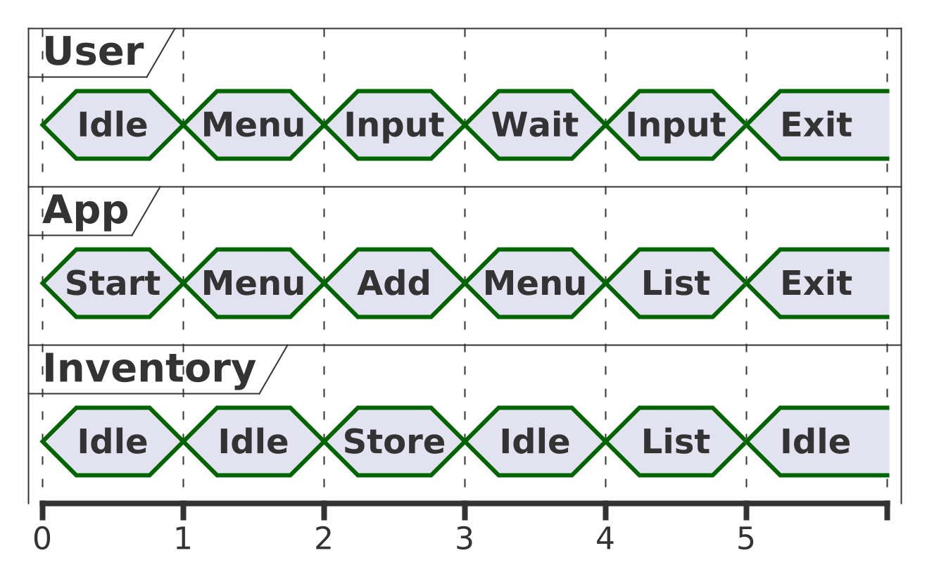

@startuml

scale 50

concise "User" as U

concise "App" as A

concise "Inventory" as I

@0

U is Idle

A is Start

I is Idle

@1

U is Menu

A is Menu

I is Idle

@2

U is Input

A is Add

I is Store

@3

U is Wait

A is Menu

I is Idle

@4

U is Input

A is List

I is List

@5

U is Exit

A is Exit

I is Idle

@enduml